**Practical 8 code**

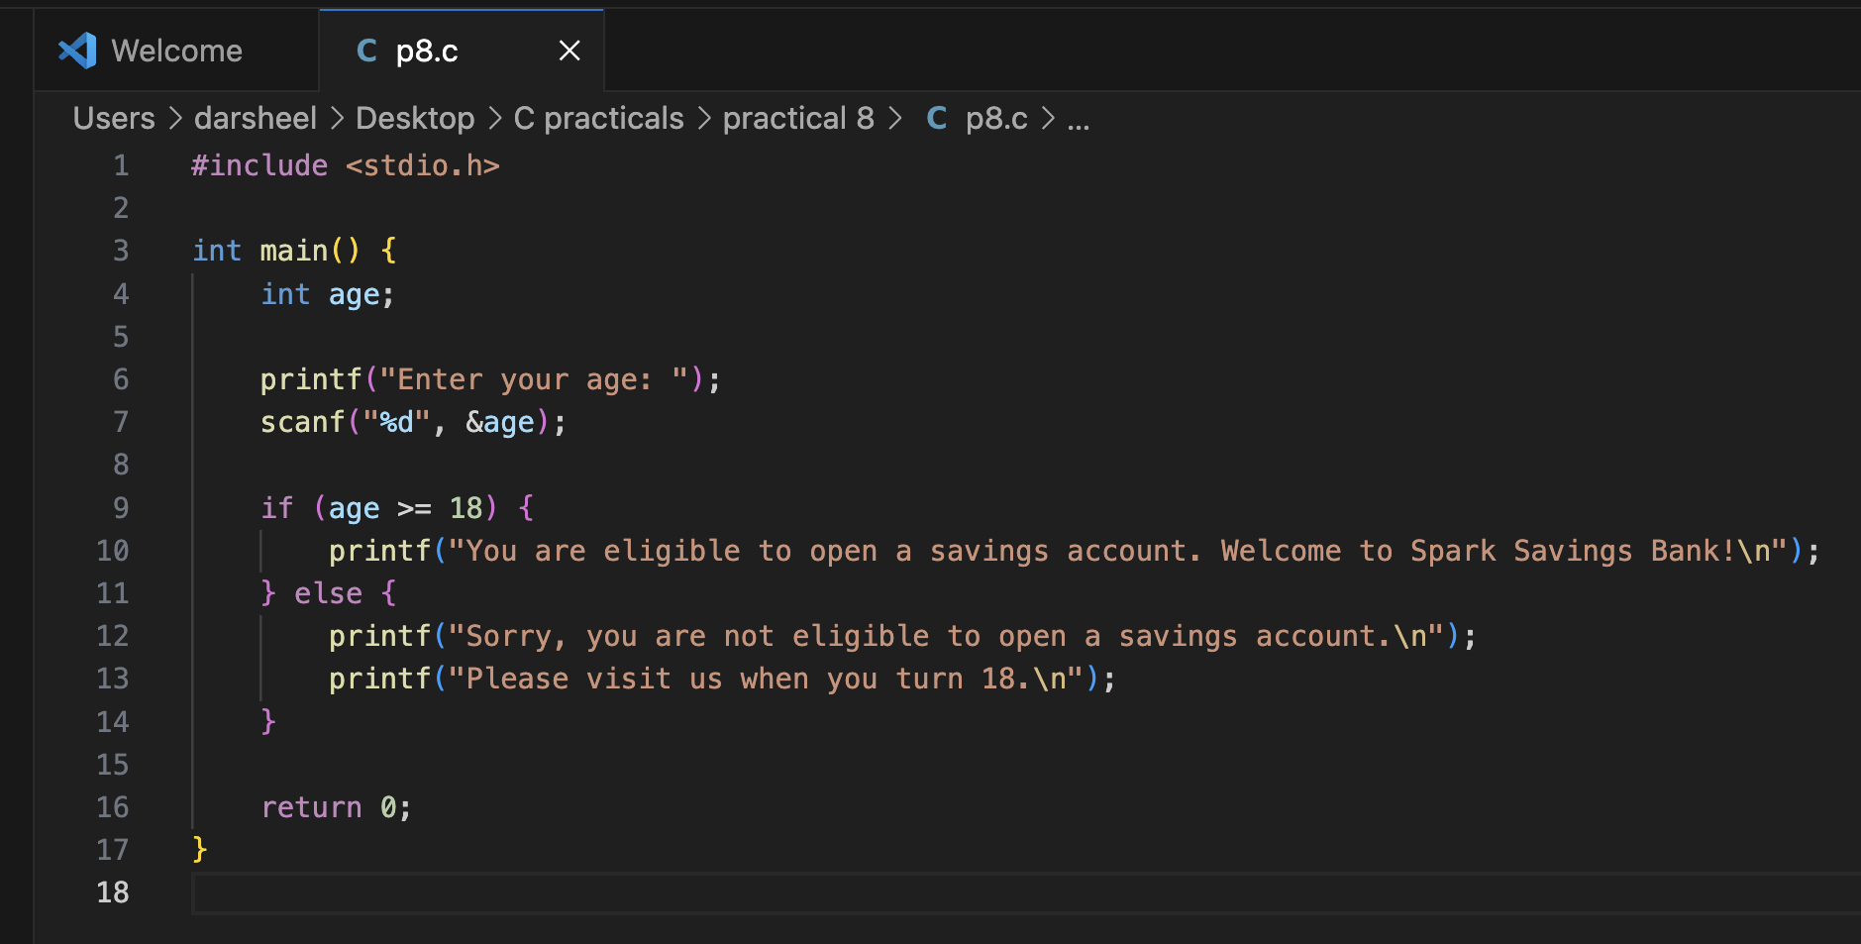

Output of the code is:

